Capstone: Real Estate Marketplace

|  |  |  |  |
| --- | --- | --- | --- |
| **Rinkeby link :** |  |  |  |
|  | | |

<https://rinkeby.etherscan.io/address/0x1D4396D3DfdFFFB57e2Ae580f175E7DFCf08759A>

<https://rinkeby.etherscan.io/address/0x15D1805DCCF1f6249EF6A8e3Bfb27A0C42841f8c>

**Open sea link :** <https://testnets.opensea.io/collection/reap>

**Steps to execute project:**

**Step-1**: Go to command prompt and type cd <space> <path to blockchain project>.

**Step-2** : Install node and npm then git, VSCode, Python, Docker

**Step-3** : Install all the dependencies by typing **“ npm install ”**

**Step-4** : Then type **“ npm install truffle ”** [Only for first time].

**Step-5** : Go to the blockchain project folder/<eth-contracts>.

**Step-6** : then type **“truffle compile”** to compile contracts.

**Step-7** : Start Ganache like below: ganache-cli -a 40 -m "before steel list survey awkward cement avocado execute napkin neglect mutual cost" .

**Step-8** : In a separate terminal window, from inside the directory eth-contracts, type **“ truffle migrate --network development --reset “** to migrate locally.

**Step-9** : Testing ERC721

File: TestERC721Mintable.js

Test minting functionality of tokens and transfer of tokens.

Type **“ truffle test test/TestERC721Mintable.js “**.

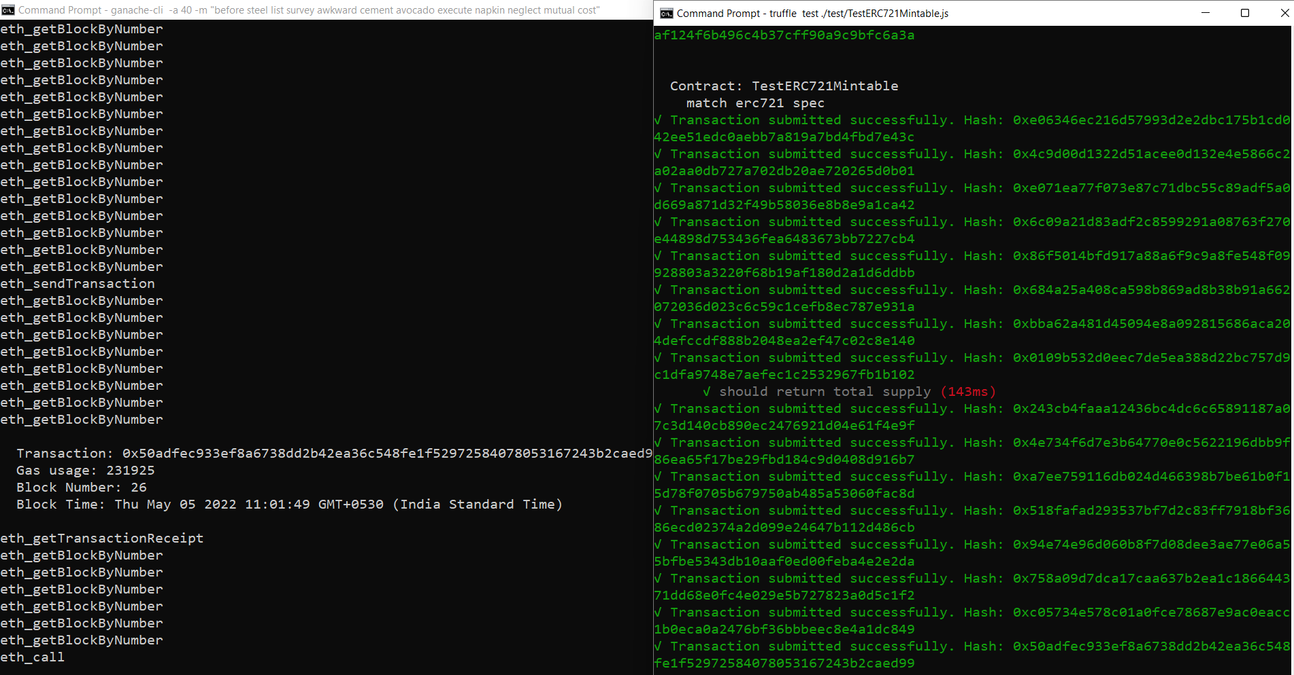

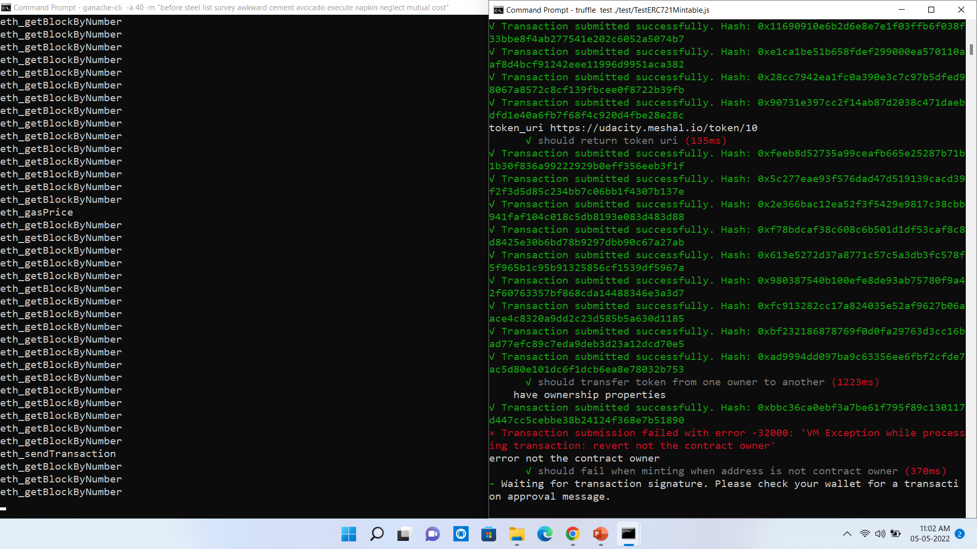

Test zkSnarks

File: TestSquareVerifier.js

Verifies zkSnarks is successfully implemented.

Type **“ truffle test test/TestSquareVerifier.js “** .

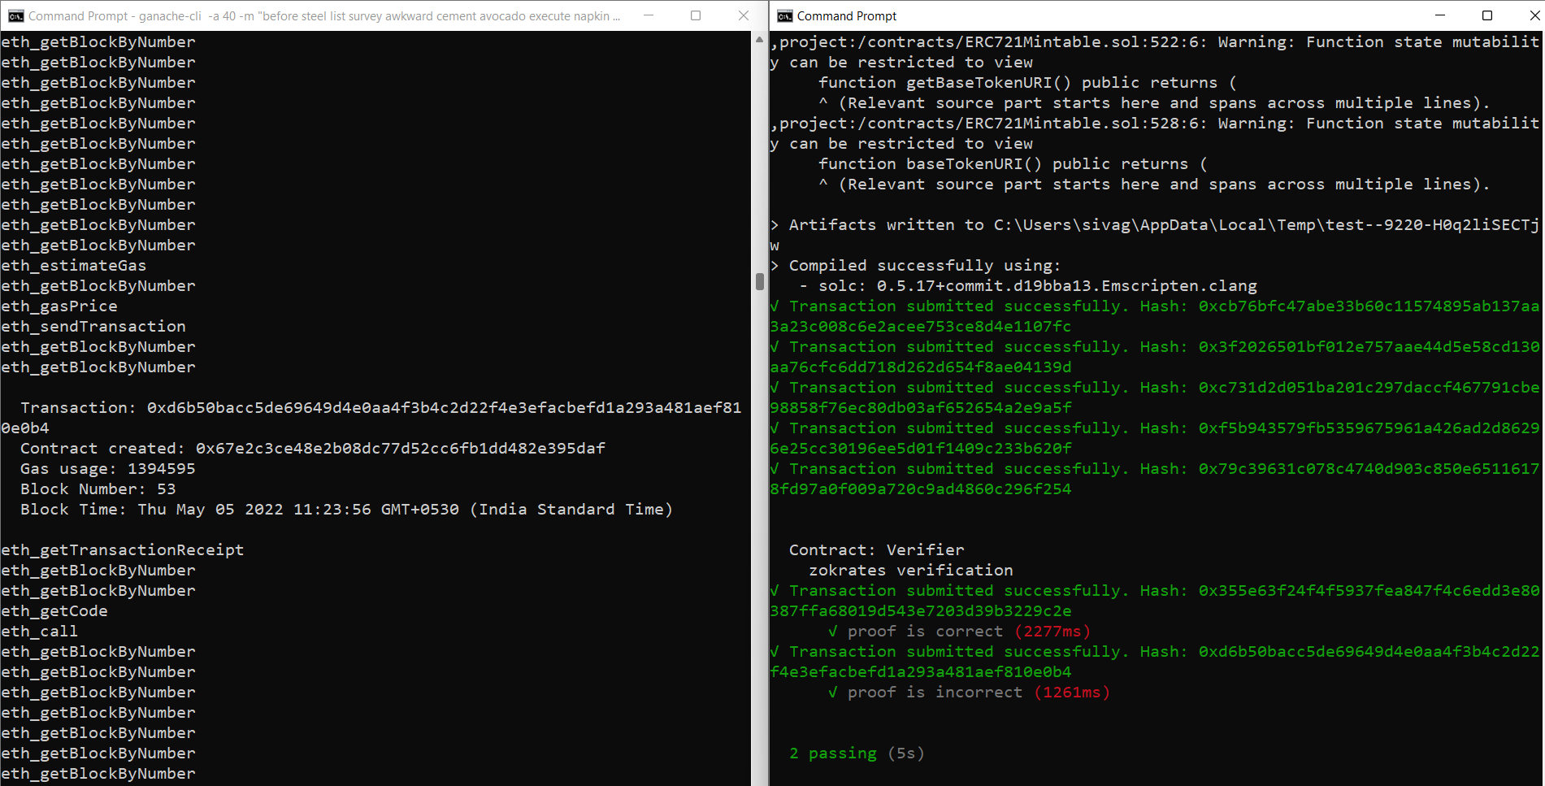

Testing ERC721 token with zkSnarks

File: TestSolnSquareVerifier.js

Test minting with zkSnarks.

Type **“ truffle test test/TestSolnSquareVerifier.js “** .

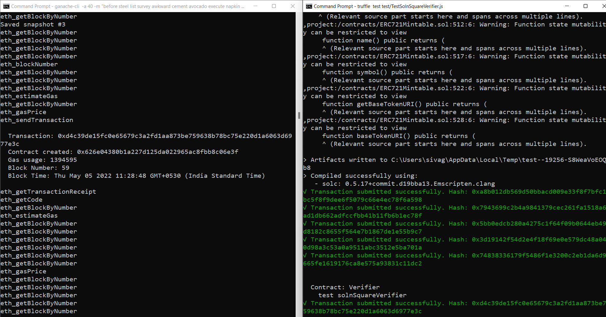

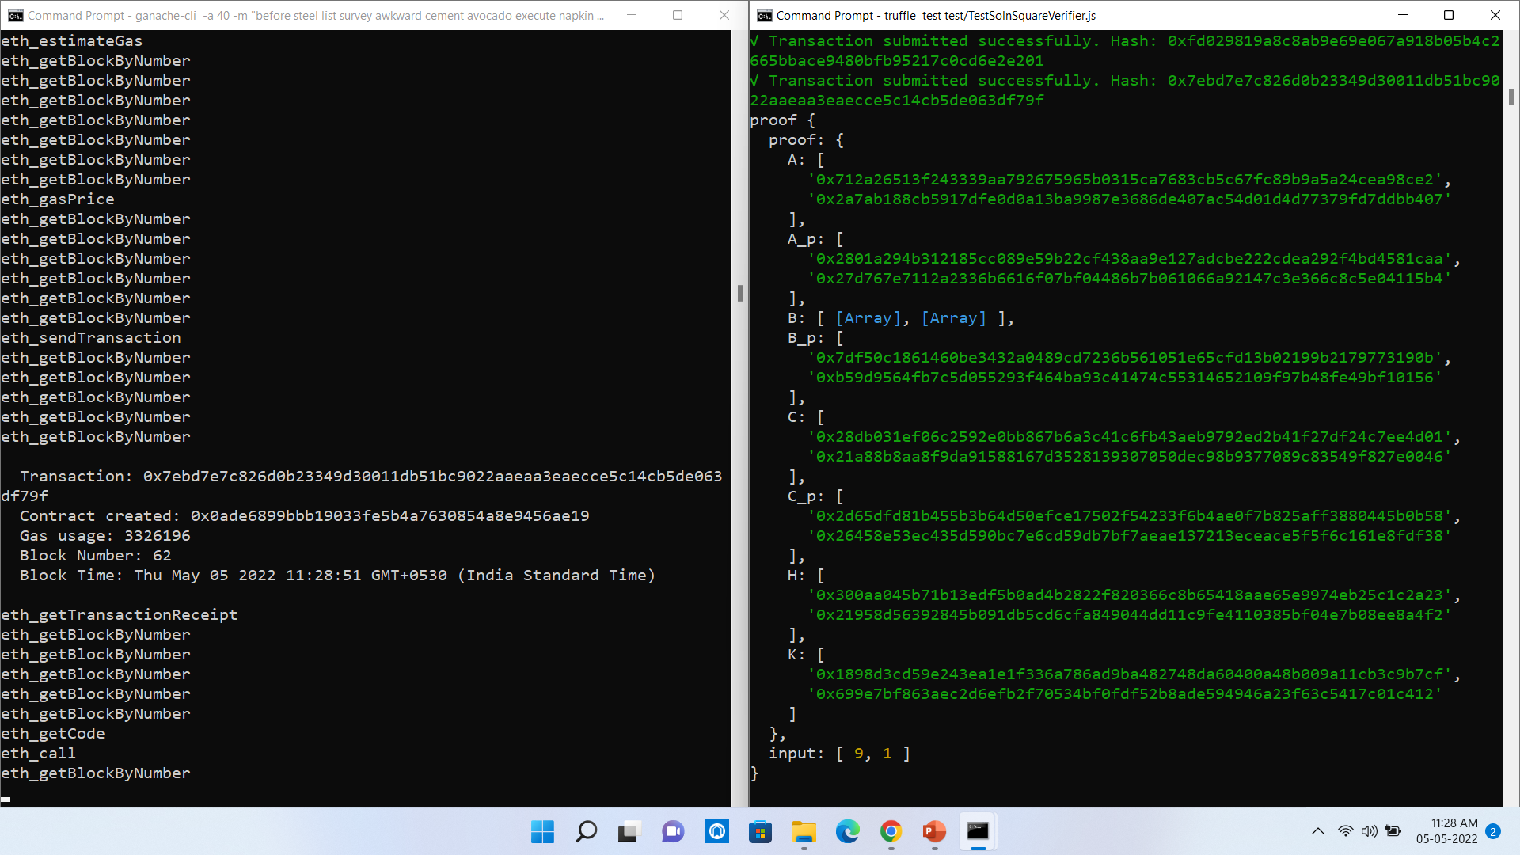

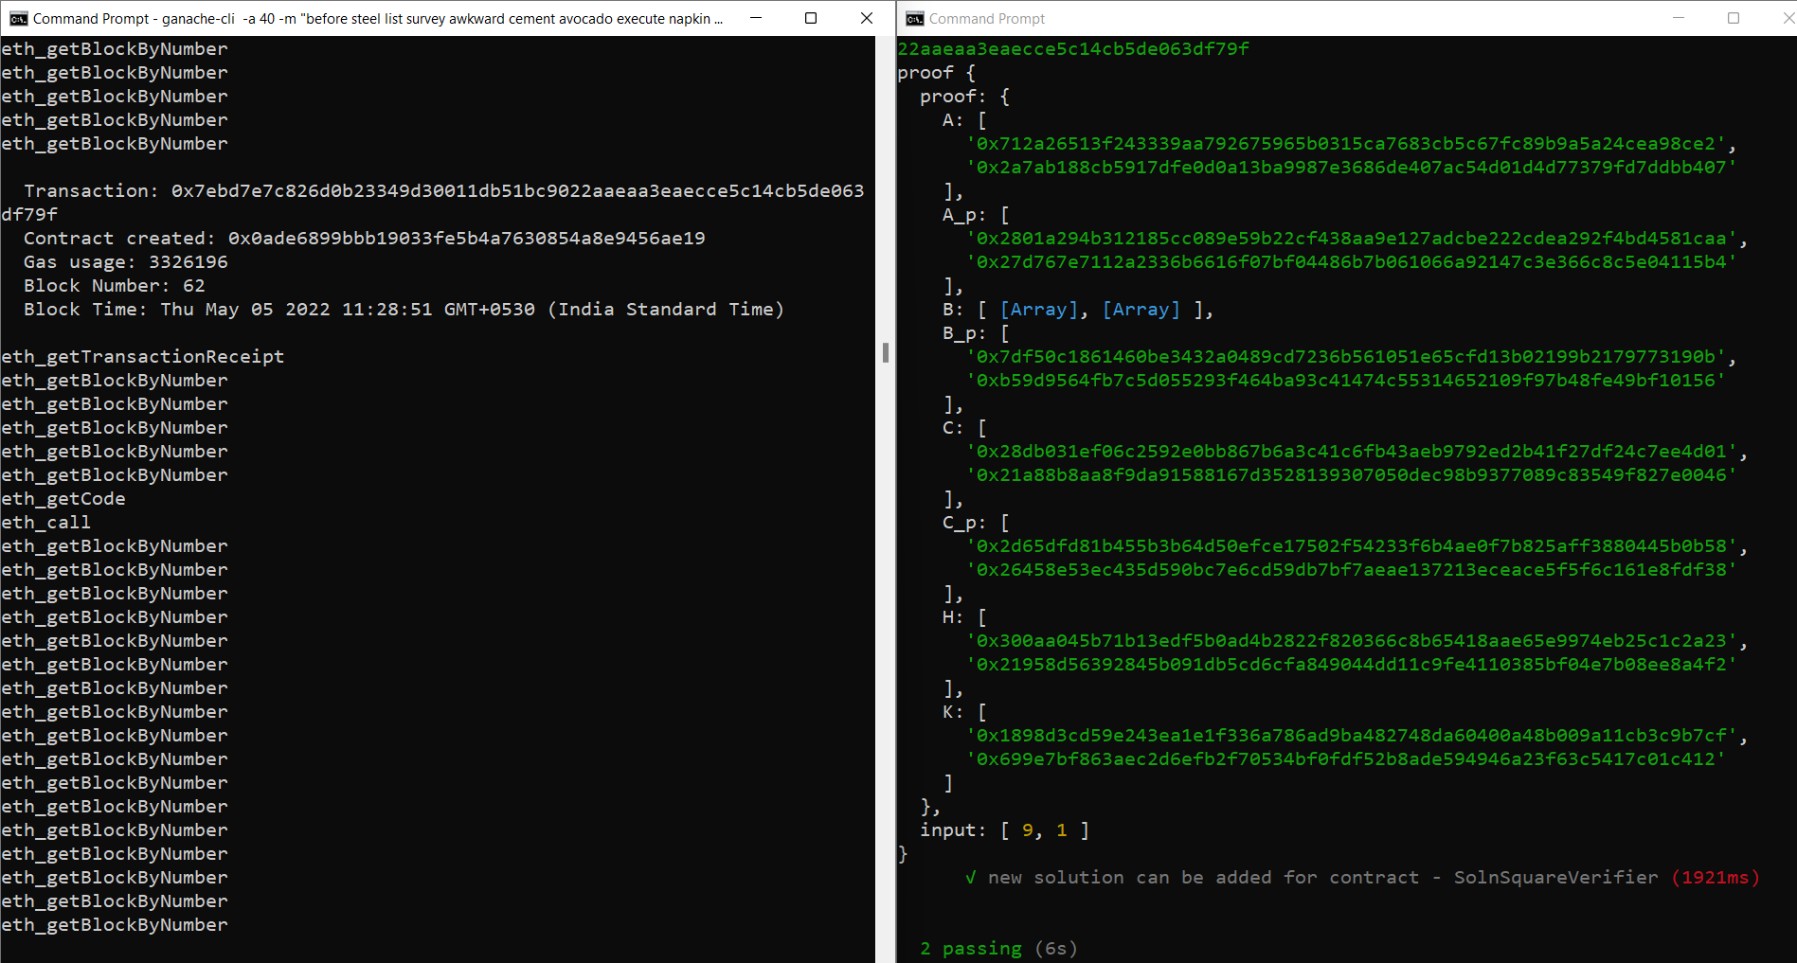

**Note:** All the tests should pass for single file tests

**Step-10** : Implement Zokrates

Type docker run -v<path to blockchain project>/zokrates/code:/home/zokrates/code -ti zokrates/zokrates:0.3.0 /bin/bash

cd code/square

~/zokrates compile -i square.code

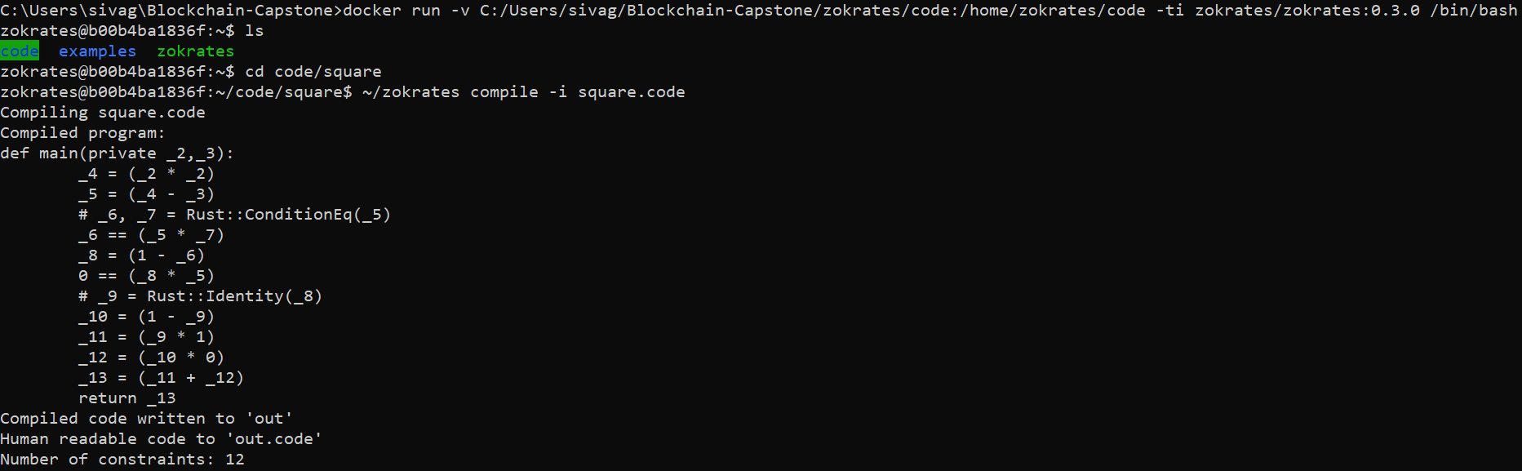

~/zokrates setup

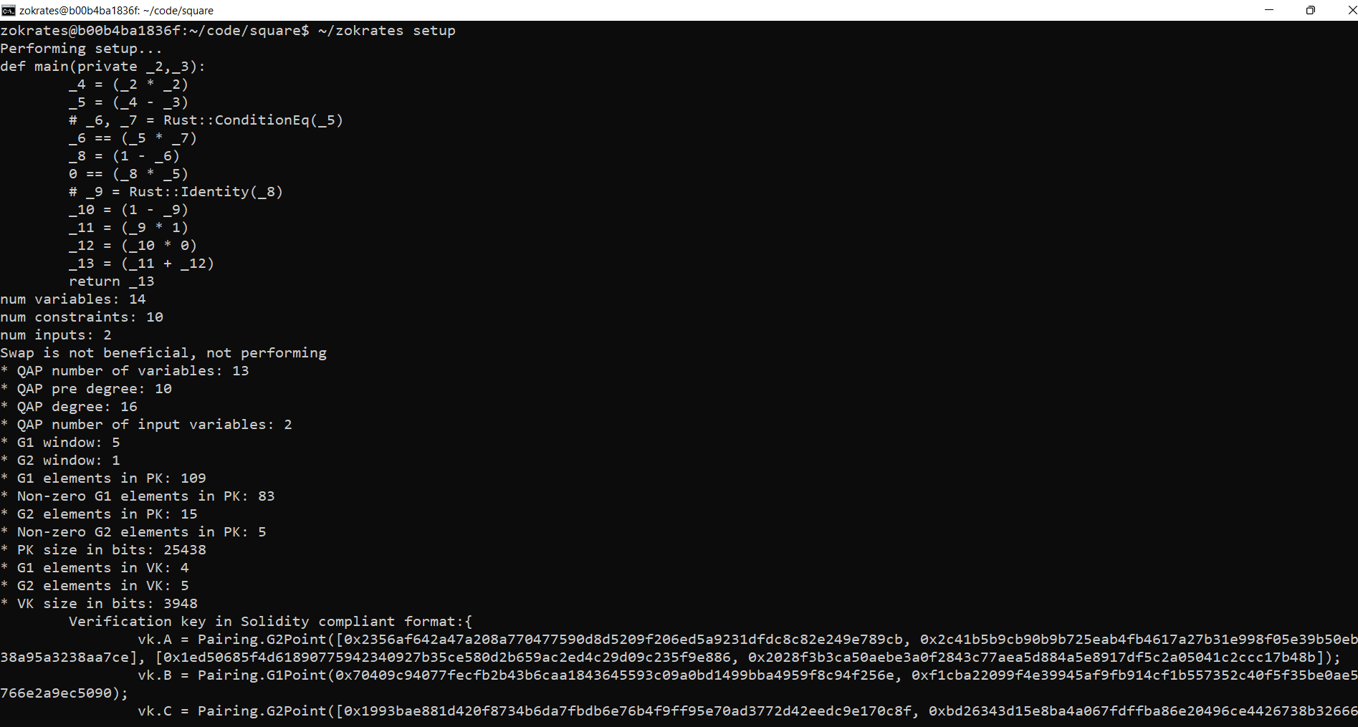

~/zokrates compute-witness -a 3 9

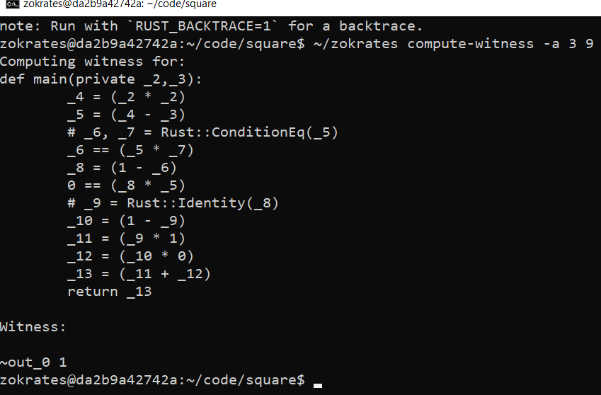

~/zokrates generate-proof

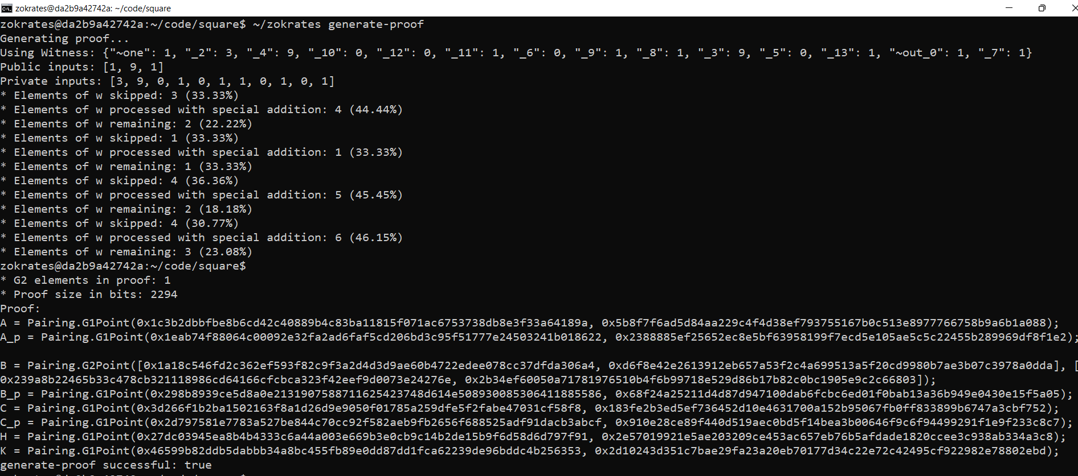

~/zokrates export-verifier

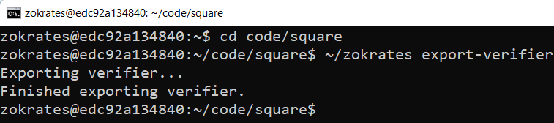

**Step-11: Rinkeby Deployment**

1. Login/create infura account to obtain Rinkeby endpoint
2. Update the truffle-config.js file to include the Rinkeby network
3. truffle compile
4. truffle migrate --network rinkeby --reset

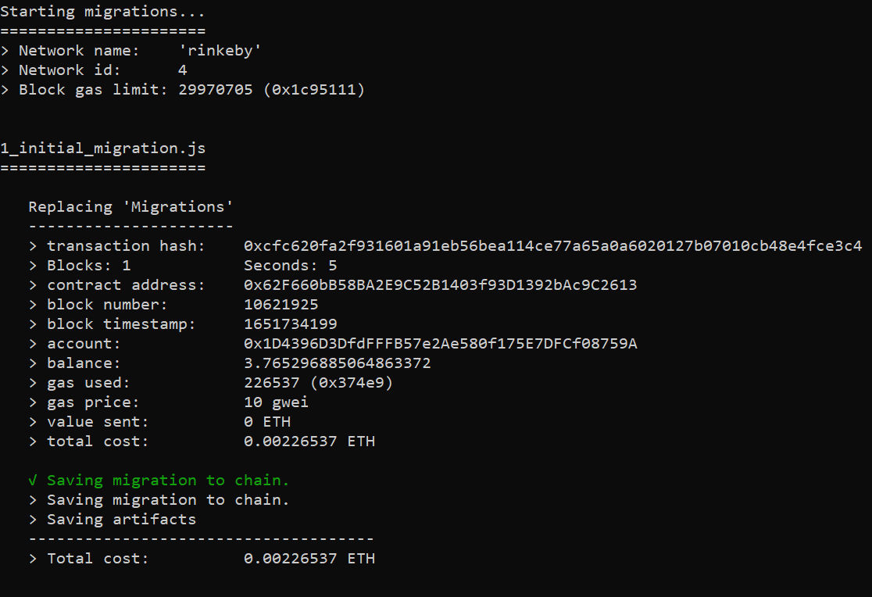

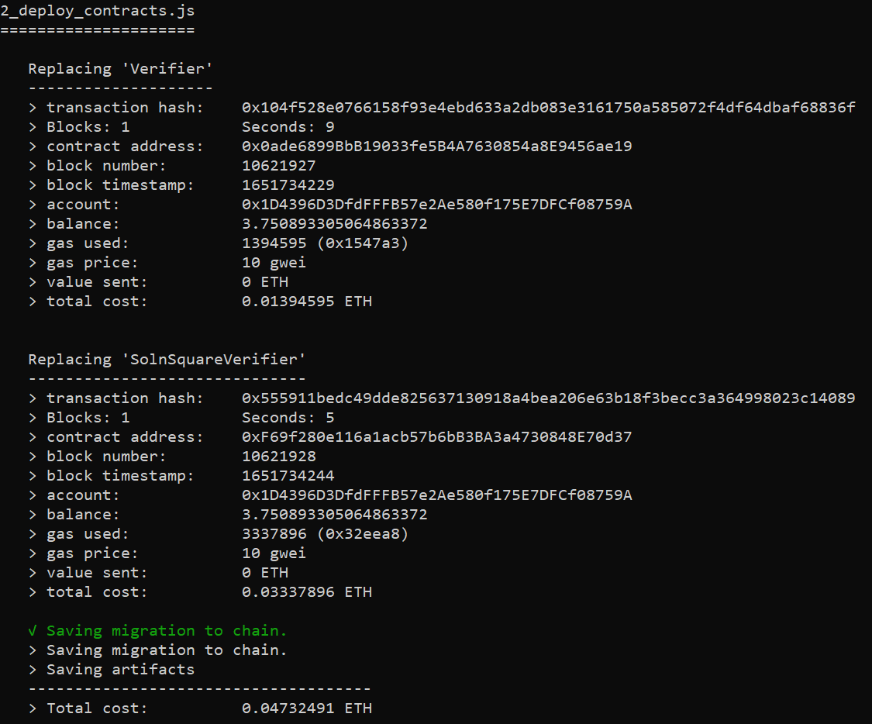

1. Install metamask as extension and access the wallet with the given 12 mnemonic Word phrases.
2. Access MyEtherWallet(MEW) using Metamask
3. Go to Interact Contract
4. To mint tokens:

From:

Contract address: present solnsquareverifier (Account-1)

To:

Account 2 address

(10 tokens)

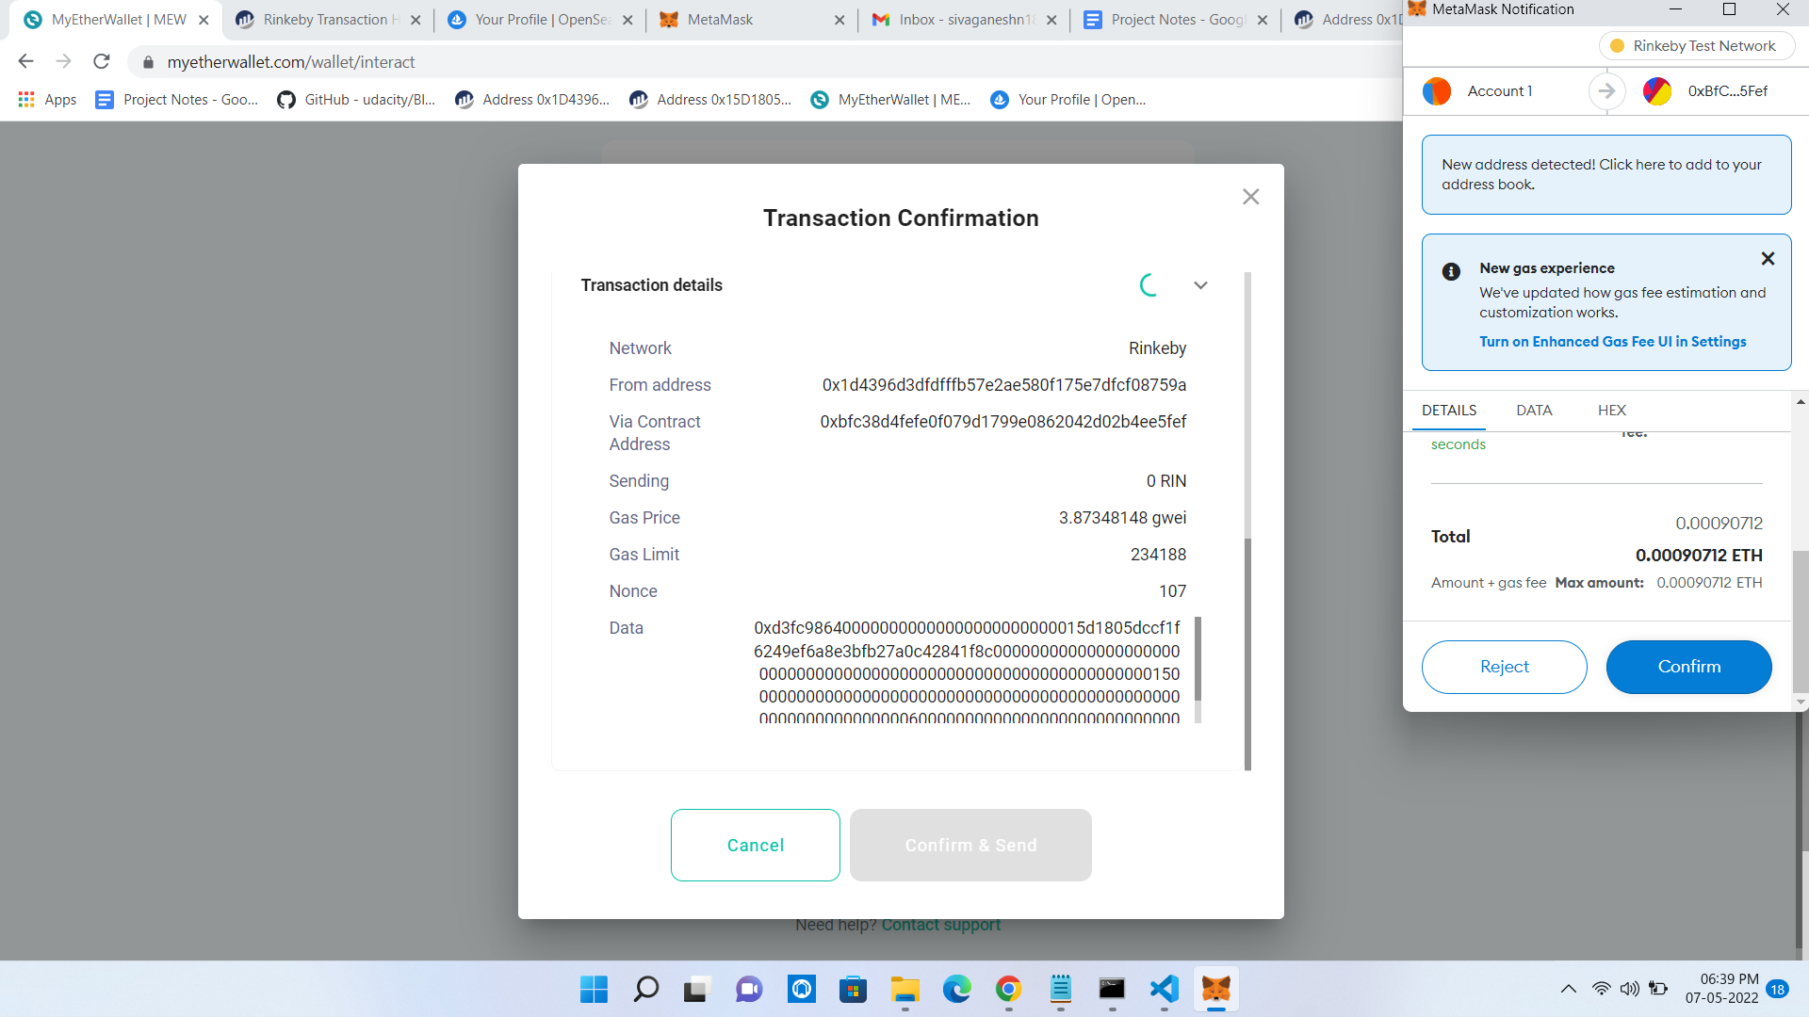

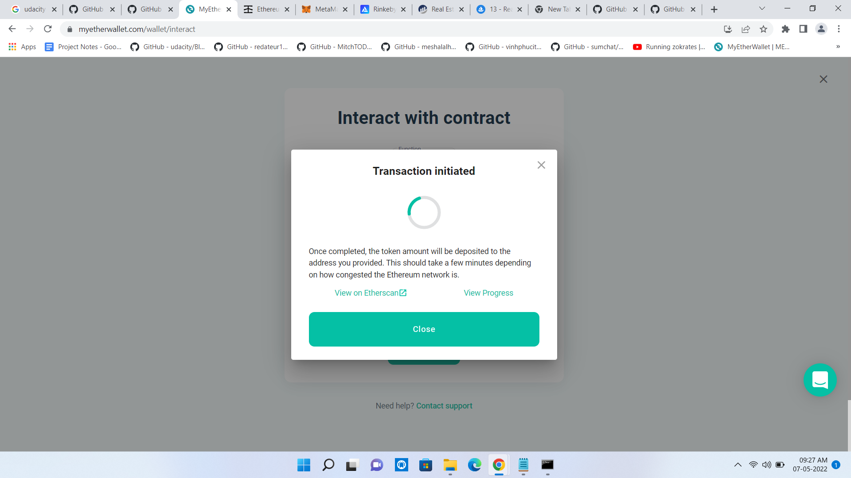

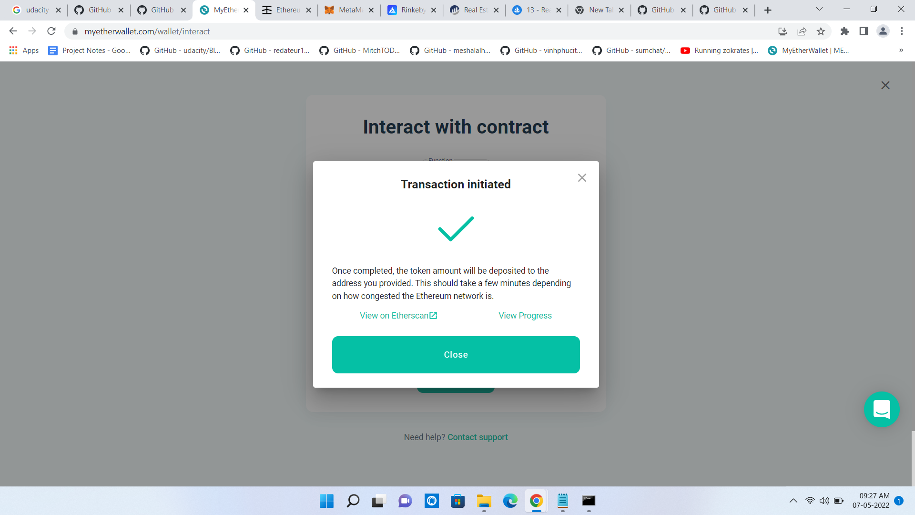

Track the transactions using metamask to speedup transactions or go to etherscan and check status.

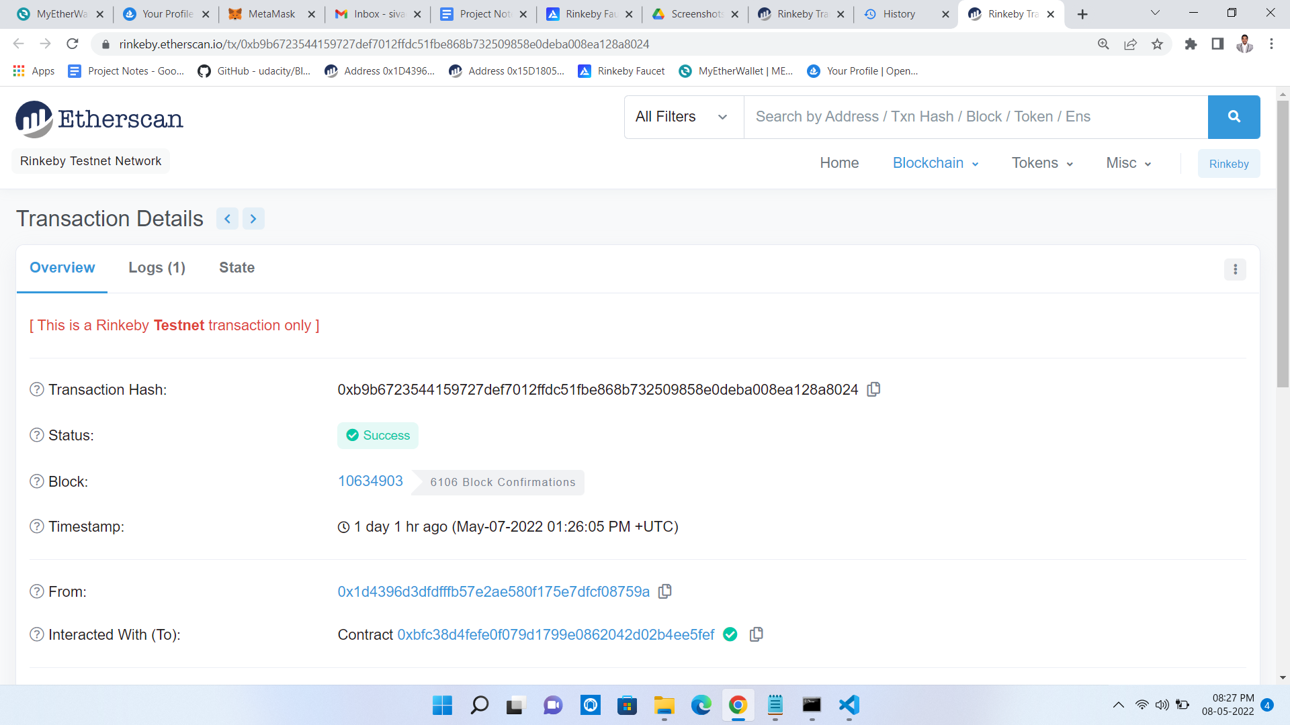

Go to this link to view the marketplace

<https://testnets.opensea.io/collection/reap>

Selling Item on Account-1(real-estate)

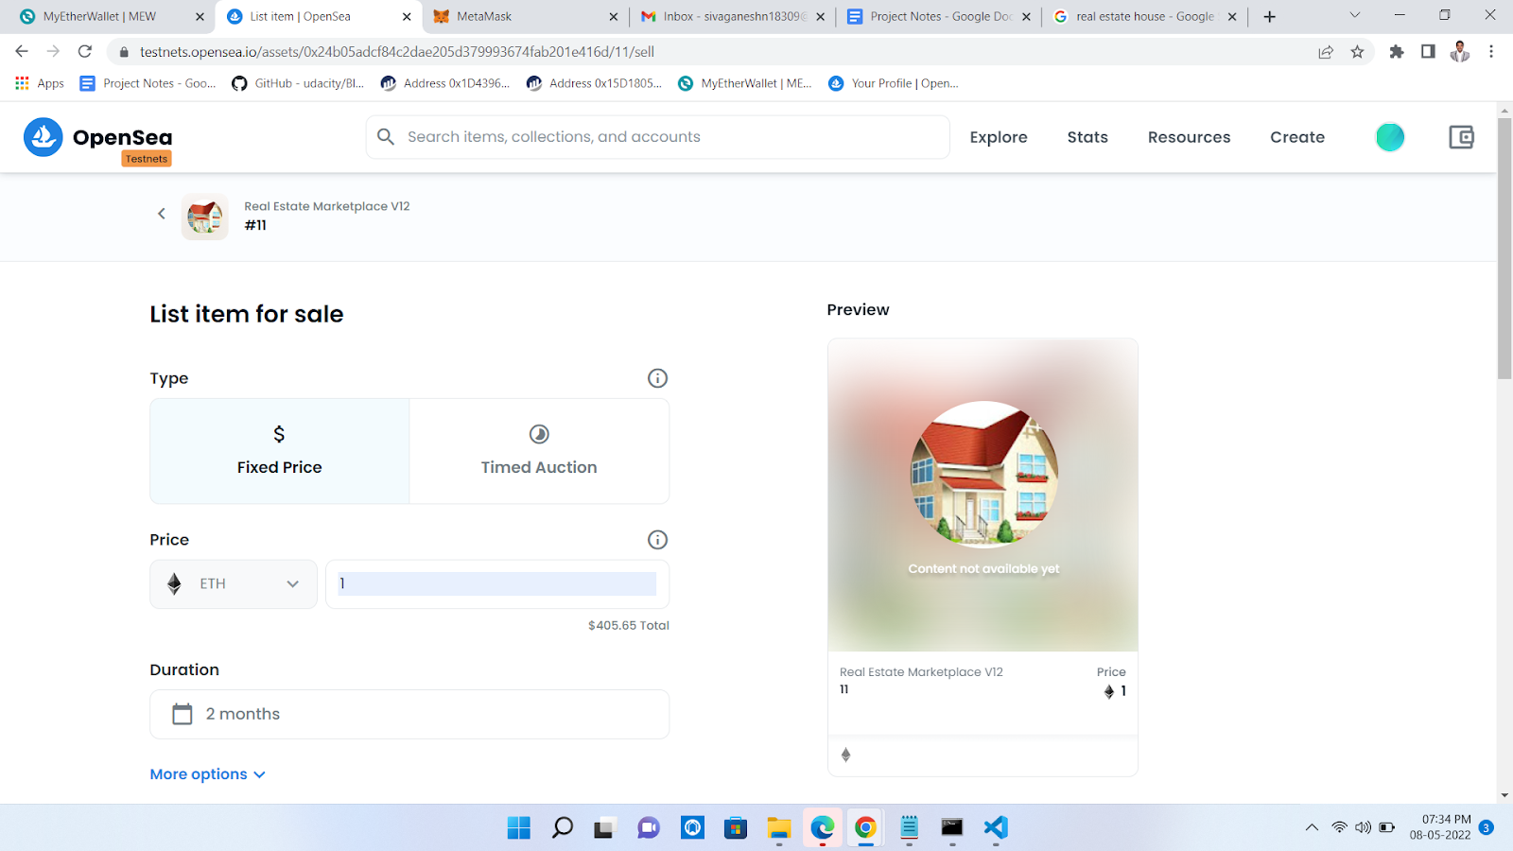

Completing Listing on Account-1(real-estate)

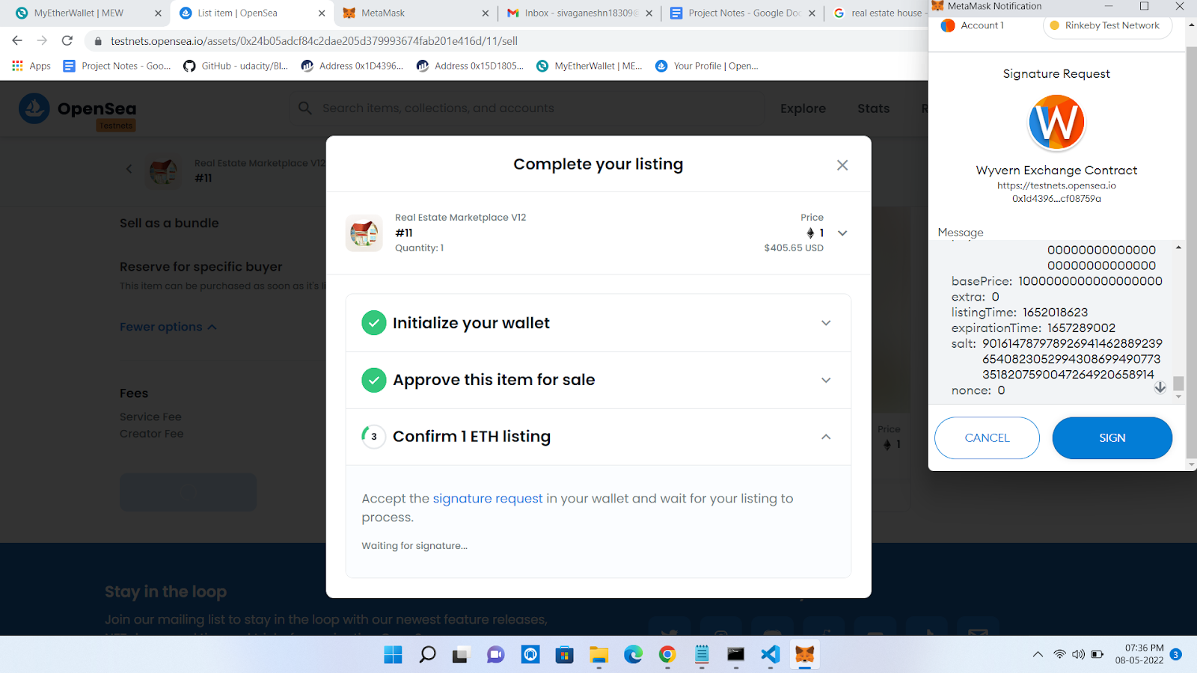Listed For Sale on Account-1(real-estate)

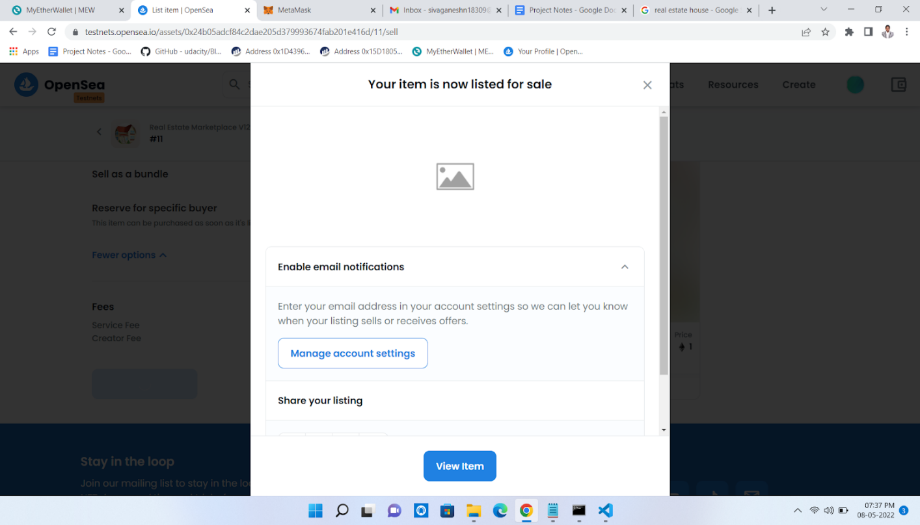

Viewed Property From Account-2(REAP)

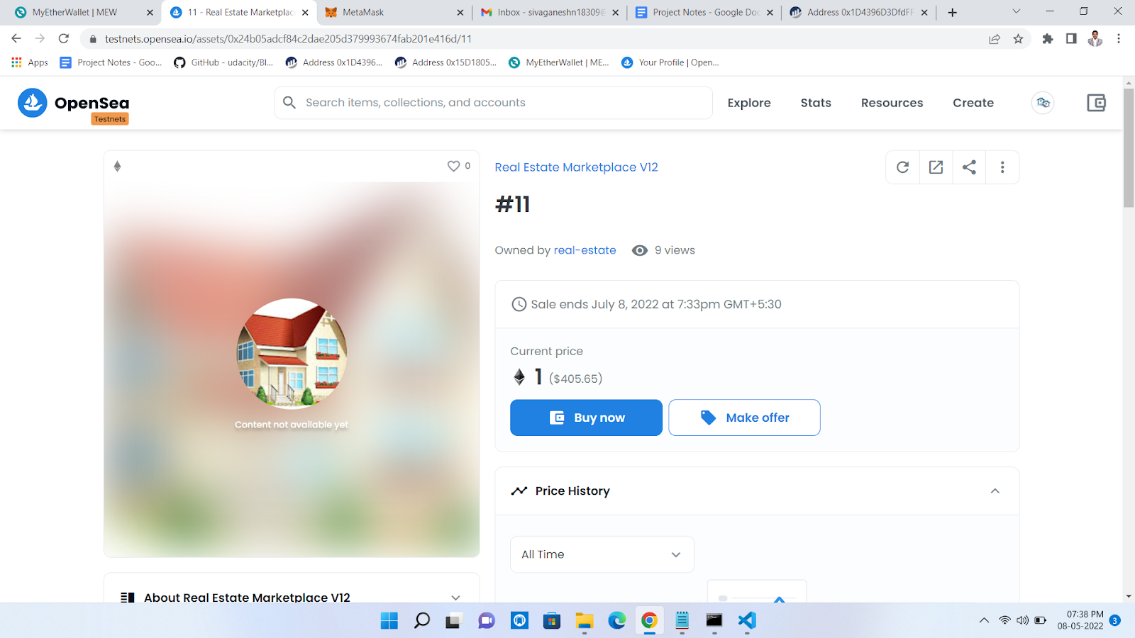

Review on clicking Buy Now

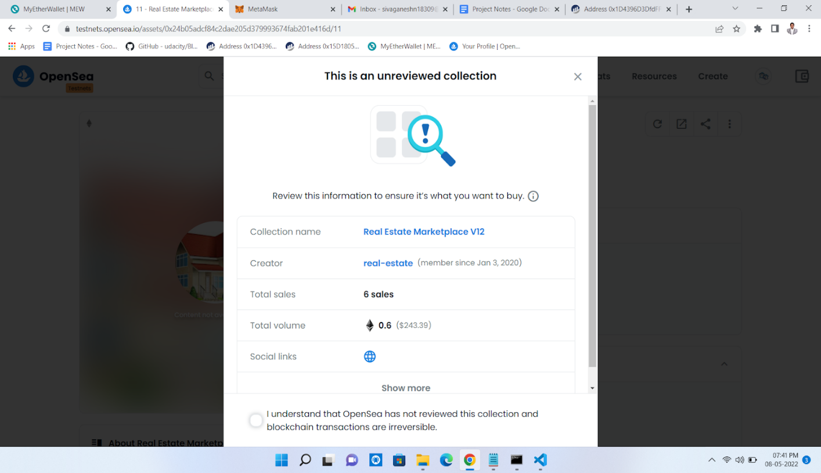

Checkout Page after consent

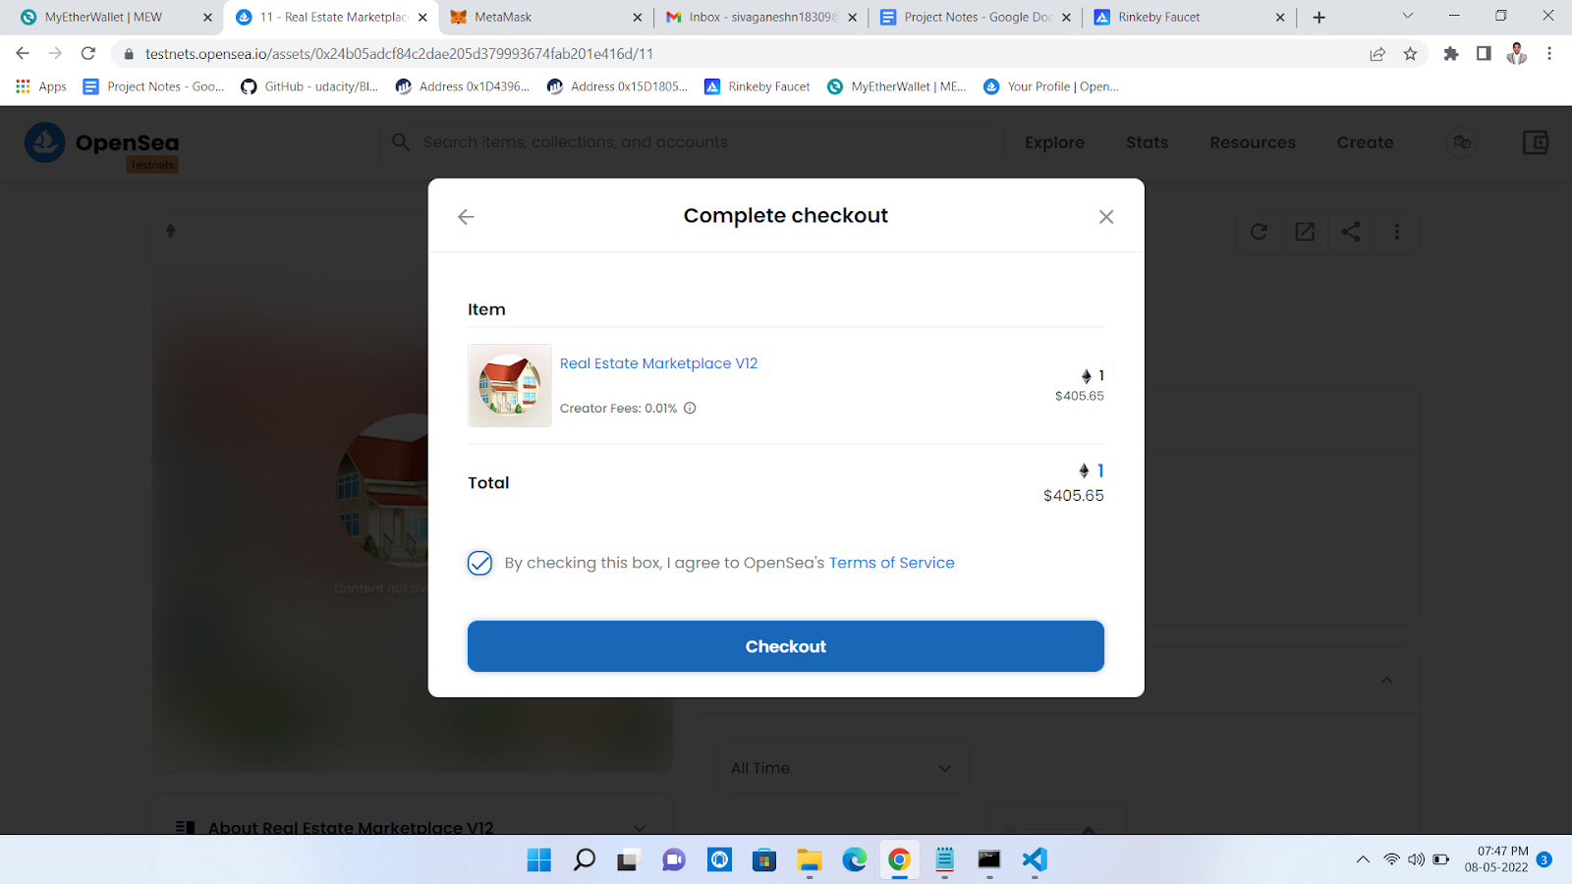

Processing Purchase after Checkout

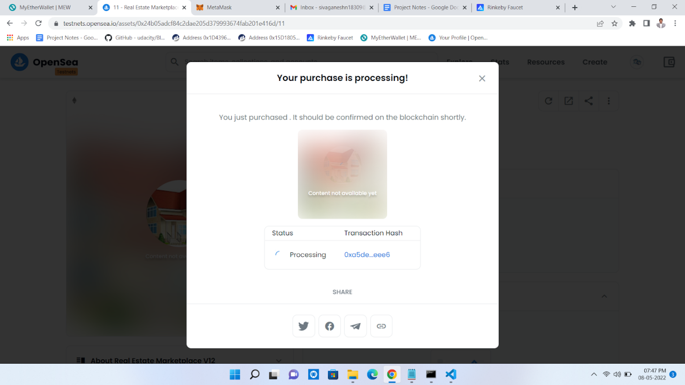

Purchase Complete

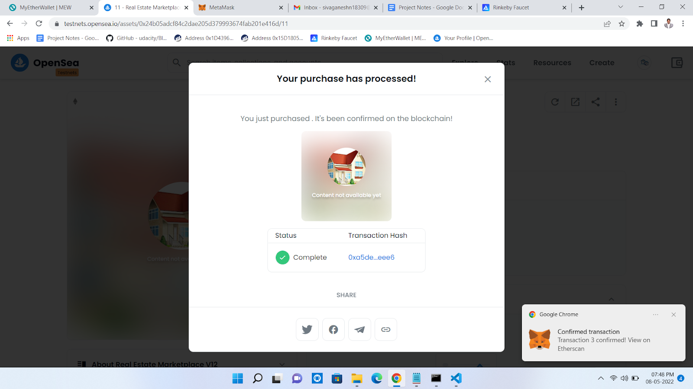

Ownership Transferred to Account-2(REAP)

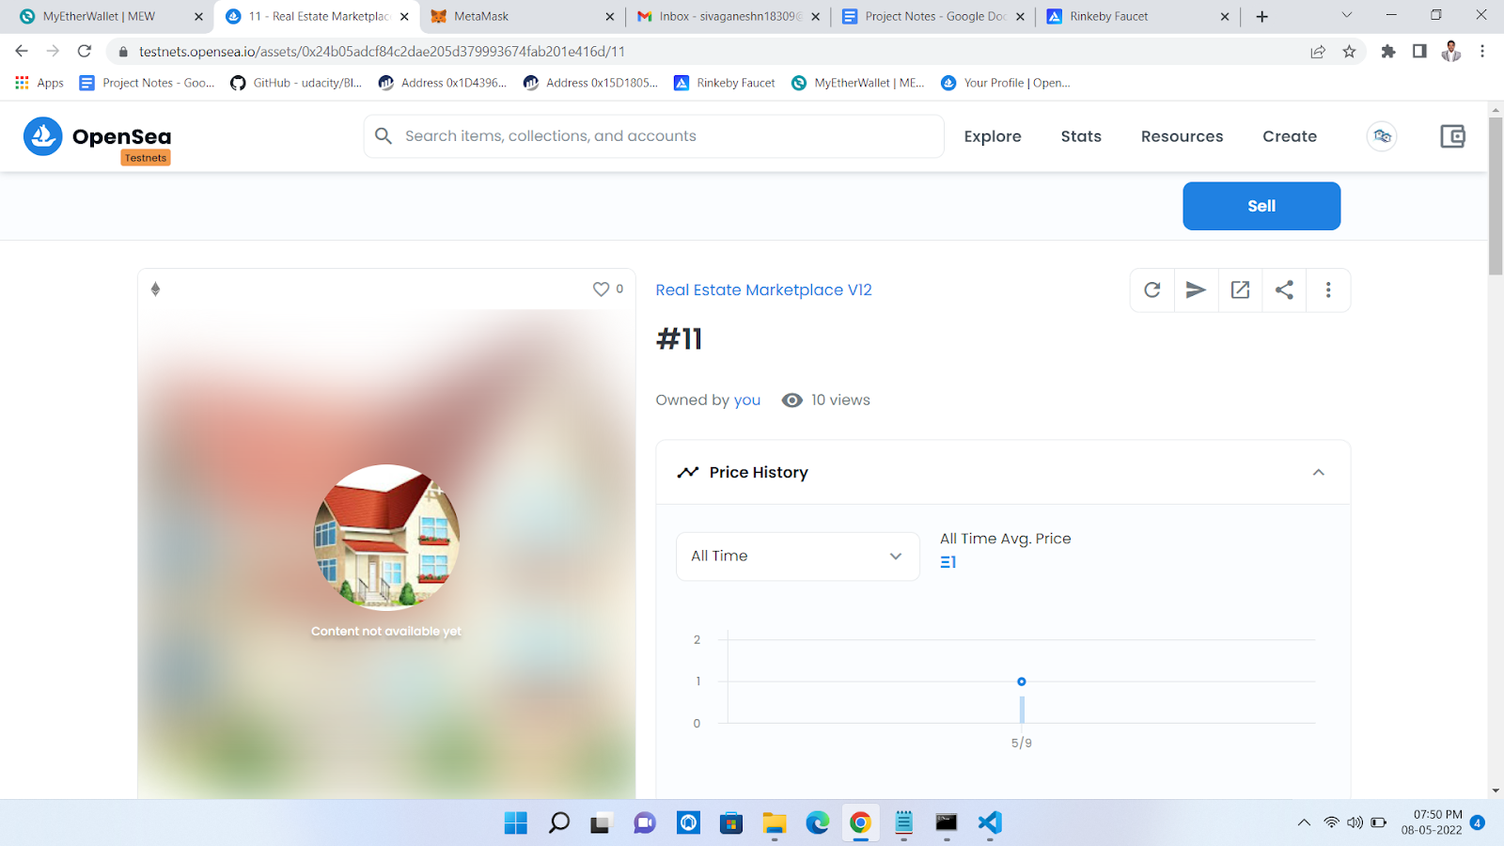

Listed on Account-2 After buy

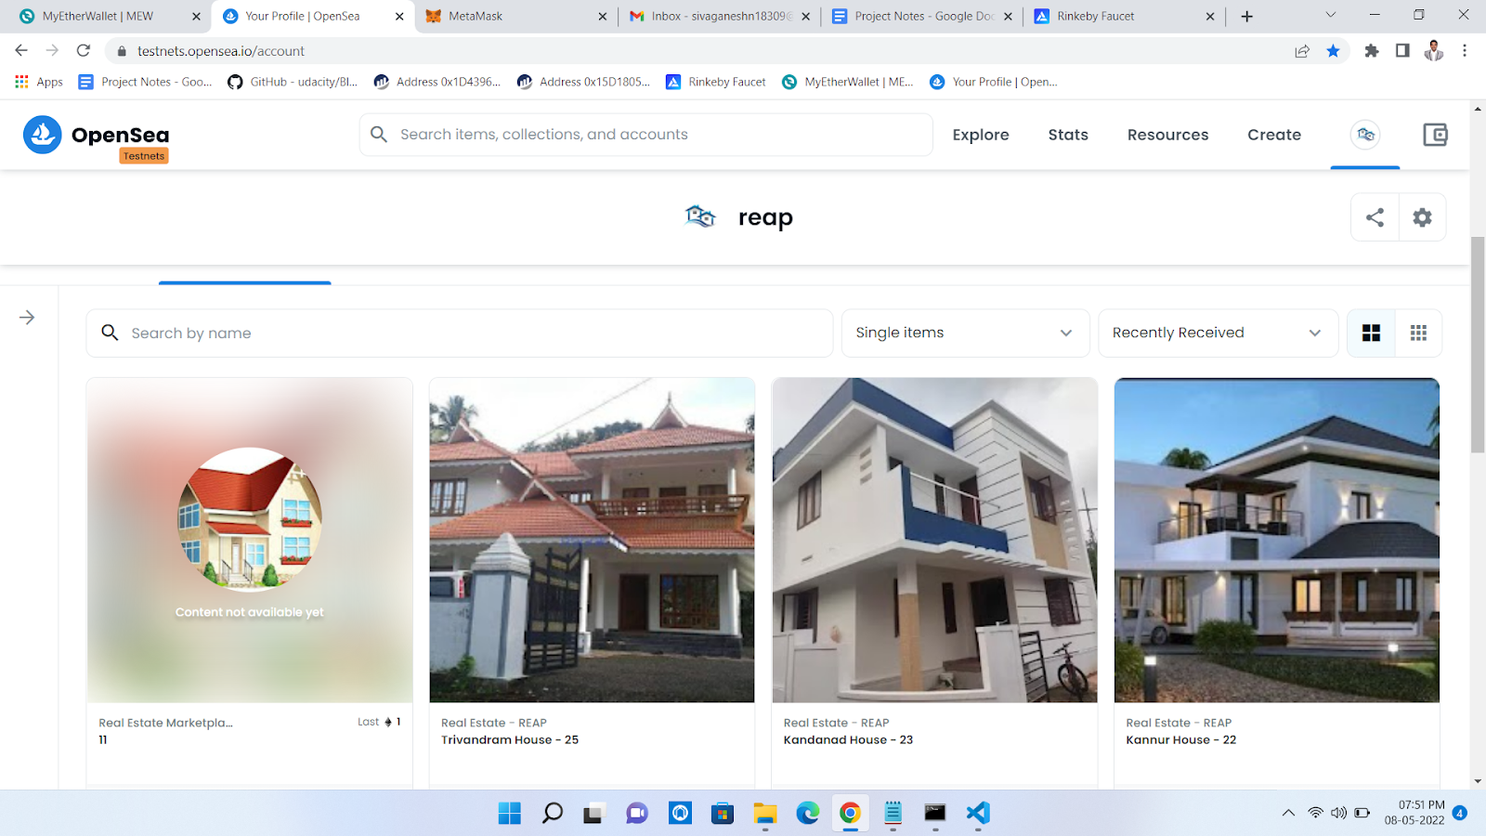

Assets Listed in Opensea:

1. <https://testnets.opensea.io/assets/0x88b48f654c30e99bc2e4a1559b4dcf1ad93fa656/9868726809177950404493602065742847302919256031804229632727434062634757914625>
2. <https://testnets.opensea.io/assets/0x88b48f654c30e99bc2e4a1559b4dcf1ad93fa656/9868726809177950404493602065742847302919256031804229632727434068132316053505>
3. <https://testnets.opensea.io/assets/0x88b48f654c30e99bc2e4a1559b4dcf1ad93fa656/9868726809177950404493602065742847302919256031804229632727434063734269542401>
4. <https://testnets.opensea.io/assets/0x88b48f654c30e99bc2e4a1559b4dcf1ad93fa656/9868726809177950404493602065742847302919256031804229632727434059336223031297>
5. https://testnets.opensea.io/assets/0x88b48f654c30e99bc2e4a1559b4dcf1ad93fa656/9868726809177950404493602065742847302919256031804229632727434058236711403521